## Table of Contents

1. Introduction
2. System Overview
3. Architecture

* High-Level Architecture
* Component Interactions

1. Backend Design
   * Technologies Used
   * Project Structure
   * API Design
   * Database Schema
   * Middleware
2. Frontend Design
   * Technologies Used
   * Project Structure
   * Routing
   * State Management
   * Key Components
3. Security Considerations
4. Deployment Plan
5. Future Plans
6. Conclusion

# Introduction and System Overview

## Introduction

**BookNXT** is a modern digital library platform designed to provide users with seamless access to books through online reading and PDF downloads across all devices. The platform emphasizes user engagement through features like ratings, comments, and personalized book collections, creating an interactive reading ecosystem that adapts to any screen size.

This design document provides a comprehensive overview of the project’s architecture, components, technology stack, and design decisions. It serves as a guide for developers, stakeholders, and contributors who are involved in the development and maintenance of the BookNXT platform.

## System Overview

BookNXT is built using the MERN stack (MongoDB, Express.js, React, Node.js), implementing modern web development practices with a focus on responsive design. The application integrates with the dbooks API for book data and maintains its own database for user information and interactions. The system is designed to provide scalability, maintainability, and responsive user experience across desktop computers, tablets, and mobile devices.

# 

# Architecture

### High-Level Architecture

The system follows a three-tier architecture, comprising:

1. **Frontend**: Developed with React.js, responsible for the client-side user interface and interactions. Features responsive design principles using Tailwind CSS for optimal display across all devices.
2. **Backend API**: Built with Express.js and Node.js, handling server-side logic, API endpoints, authentication, and business logic. Optimized for handling requests from various devices and screen sizes.
3. **Database**: Utilizes MongoDB for storing user data, saved books, ratings, and comments.
4. **External Integration**: Connects with dbooks API for comprehensive book information, with adaptive data loading based on device capabilities.

### Component Interactions

The system components interact through standardized interfaces:

1. **Client-Server Communication**:
   * JWT-based authentication
   * JSON data format for requests and responses
2. **Database Operations**:
   * MongoDB Atlas cloud database
   * Mongoose ODM for data modeling
   * CRUD operations for user data and book interactions
   * Efficient data querying for responsive interfaces
3. **External API Integration**:

* dbooks API for book information
* Error handling and response parsing
* Data transformation and caching

# Backend Design

### Technologies Used

* **Node.js**: JavaScript runtime environment
* **Express.js**: Web application framework
* **MongoDB**: NoSQL database for data persistence
* **Mongoose**: ODM for MongoDB
* **JWT**: Authentication and authorization
* **bcrypt**: Password hashing
* **Axios**: HTTP client for API requests

### Project Structure

backend/  
├── config/  
│ ├── database.js  
│ └── jwt.js  
├── controllers/  
│ ├── authController.js  
│ ├── bookController.js  
│ └── userController.js  
├── middleware/  
│ ├── auth.js  
│ ├── deviceDetection.js  
│ └── errorHandler.js  
├── models/  
│ ├── User.js  
│ ├── Book.js  
│ └── Comment.js  
├── routes/  
│ ├── auth.js  
│ ├── books.js  
│ └── users.js  
├── services/  
│ └── dbooksService.js  
└── server.js

### API Design

The backend exposes RESTful API endpoints categorized under:

#### **Authentication (/api/auth)**

* POST /register: User registration with device information
* POST /login: User authentication
* POST /logout: User logout
* GET /verify: Token verification

#### **Books (/api/books)**

* GET /search: Search books through dbooks API with device-optimized results
* GET /:id: Get specific book details
* GET /:id/download: Download book PDF with device-specific optimization
* POST /:id/rate: Rate a book
* POST /:id/comment: Add comment to a book

#### **User (/api/users)**

* GET /saved-books: Get user’s saved books with responsive pagination
* POST /save-book: Save a book to collection
* DELETE /saved-books/:id: Remove book from collection
* GET /profile: Get user profile information

### Database Schema

#### **User Model**

Fields: - username (String, required) - email (String, required, unique) - password (String, required) - savedBooks (Array of References to Book) - devicePreferences (Object) - createdAt (Date) - updatedAt (Date)

#### **Book Model**

Fields: - bookId (String, required) - title (String, required) - authors (Array of Strings) - pages (Number) - publisher (String) - year (Number) - description (String) - imageUrls (Object with different sizes) - ratings (Array of Rating Objects) - comments (Array of Comment Objects)

#### **Rating Schema**

Fields: - userId (Reference to User) - rating (Number) - deviceType (String) - createdAt (Date)

#### **Comment Schema**

Fields: - userId (Reference to User) - text (String) - deviceType (String) - createdAt (Date)

### Middleware

#### **Authentication Middleware**

* Validates JWT tokens
* Protects routes requiring authentication
* Handles device-specific authentication flows

#### **Device Detection Middleware**

* Identifies client device type
* Sets appropriate response headers
* Optimizes response format

#### **Error Handling Middleware**

* Centralizes error handling
* Formats error responses
* Provides device-specific error messages

# 

# Frontend Design

### 

### Technologies Used

* **React.js**: UI library
* **Redux**: State management
* **React Router**: Client-side routing
* **Material-UI**: Component library with responsive features
* **Tailwind CSS**: Utility-first CSS framework for responsive styling
* **Axios**: HTTP client
* **PDF.js**: PDF rendering
* **Chart.js**: Analytics visualization
* **React-Device-Detect**: Device detection and adaptation

### Responsive Design Implementation

1. **Breakpoints**

* Desktop Computers: 1440px
* Laptops : 1024px
* Tablets: 768px
* Mobiles: 426px

1. **Responsive Features**
   * Fluid typography using rem units
   * Flexbox layouts
   * Touch-friendly interface elements
   * Adaptive image sizing

### Project Structure

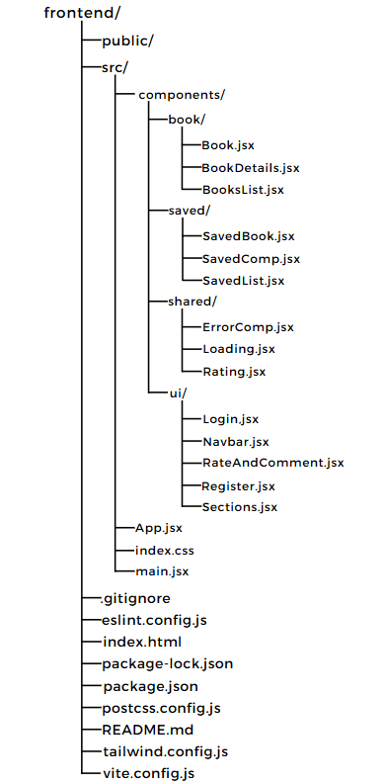

### Routing

The application implements responsive routing:

* /: Responsive home page with featured books
* /search: Adaptive book search interface
* /book/:id: Responsive book details
* /saved-books: Responsive user’s book collection
* /profile: Adaptive user profile and settings

### Key Components

#### **Responsive Navigation**

* Collapsible menu for mobile devices
* navigation on smaller screens
* Dynamic search bar placement

#### **Book Reader**

* Touch-enabled page navigation
* Adaptive zoom controls
* Device-oriented display options
* Screen orientation handling

#### **Book Collection**

* Responsive flexbox system
* Touch-friendly card interfaces
* Adaptive list view toggle
* Mobile-optimized filtering

#### **Search Interface**

* Collapsible advanced search filters
* Touch-friendly input elements
* Responsive results layout
* Quick preview

# 

# Security Considerations

### Authentication

* Device-aware JWT implementation
* Secure password hashing with bcrypt
* Multi-device token management
* Protection against brute force attacks

### Data Protection

* Input validation across devices
* XSS prevention
* CSRF protection
* Device-specific rate limiting
* Secure data storage on mobile devices

### API Security

* HTTPS enforcement
* Secure headers implementation
* Request validation
* Device-specific error handling

# Deployment Plan

### Environment Setup

* Development environment with device testing
* Staging environment for cross-device testing
* Production environment with CDN integration
* Mobile testing environment

### Deployment Steps

1. **Database Deployment**
   * MongoDB Atlas cluster setup
   * Data migration strategy
2. **Backend Deployment**
   * Environment configuration
   * API deployment with mobile optimization
   * Monitoring setup
   * Load testing across devices
3. **Frontend Deployment**
   * Build optimization for different devices
   * CDN configuration
   * Progressive Web App setup
   * Performance monitoring
4. **Mobile Testing**
   * Cross-device testing
   * Performance validation
   * Responsive design verification
   * Touch interaction testing

# Future Plans

### 

### Short-term Enhancements

* Advanced responsive search filters
* Reading progress tracking across devices
* Social sharing features
* Enhanced mobile offline capabilities
* Progressive Web App implementation

### Medium-term Goals

* Native mobile application development
* Cross-device synchronization
* Enhanced offline capabilities
* User reading statistics
* Device-specific optimizations

### Long-term Vision

* Community features with device-aware interactions
* AI-powered recommendations
* Extended format support
* Premium features with device-specific benefits
* Cross-platform integration

# Conclusion

BookNXT represents a modern approach to digital book access and management, built on the robust MERN stack with comprehensive responsive design implementation. The platform’s architecture ensures seamless operation across all devices while maintaining high performance and user engagement. The responsive design approach, combined with device-specific optimizations, provides an optimal reading experience regardless of the user’s chosen device.

The system’s modular design and mobile-first approach position it well for future enhancements while maintaining security and performance standards. As BookNXT continues to evolve, this technical foundation will support new features and capabilities across an expanding range of devices and use cases.